# Create a Lambda function and test

## NodeJs lambda

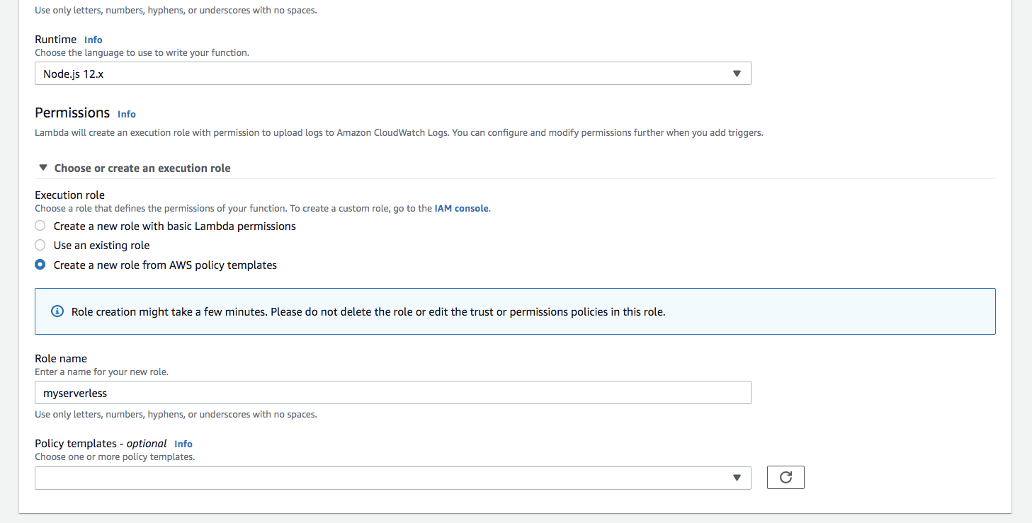

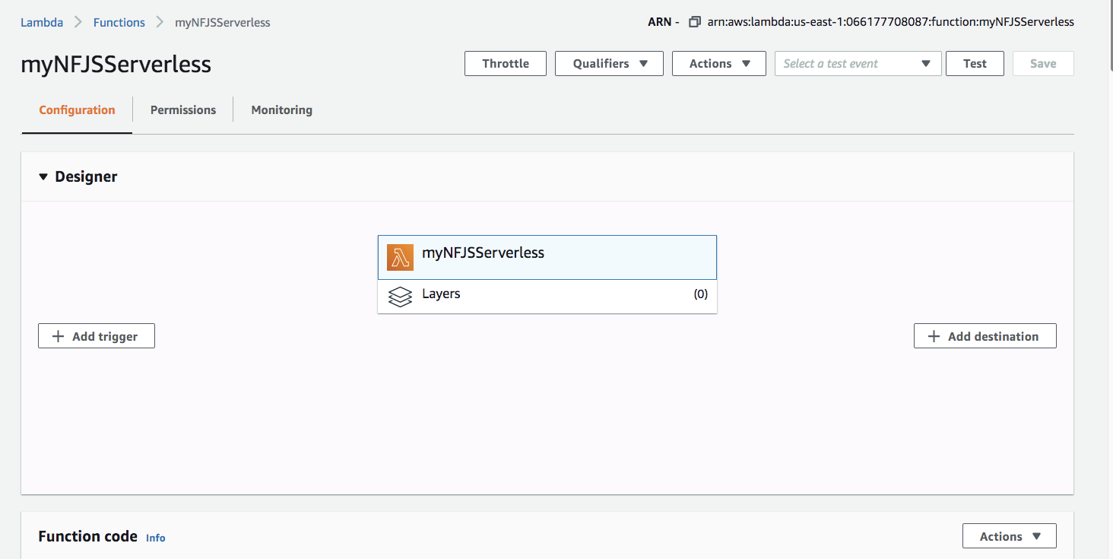

## Copy the following message

var greets = [

"Hello NFJS!",

"Hello Awesome Serverless!",

"Today is a great day!",

"Go Lambda function!",

"I am expecting miracles",

"Go get it!",

"Twinkle Twinkle Little star!",

"How I wonder what you are",

"Love the serverless!",

"Cool apps using serverless!"

];

exports.handler = (event, context, callback) => {

let greet = greets[Math.floor(Math.random()*10)];

callback(null, greet);

};

## Test the Lambda function

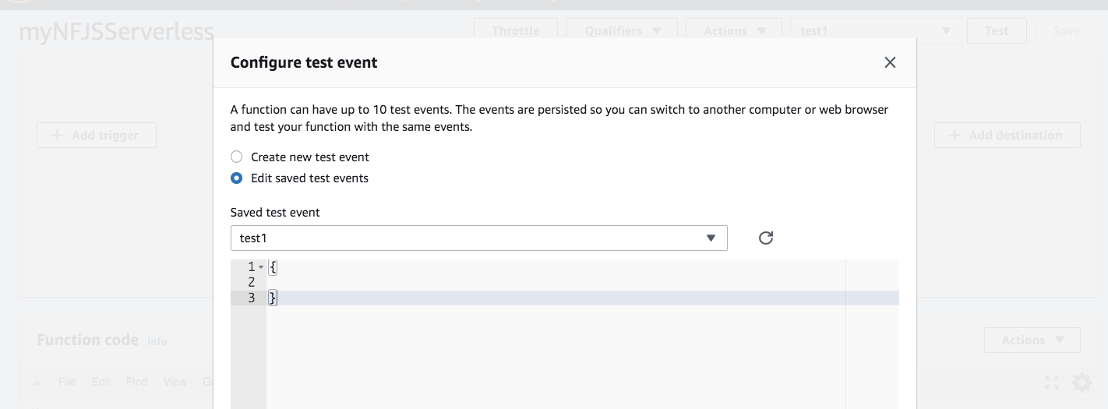

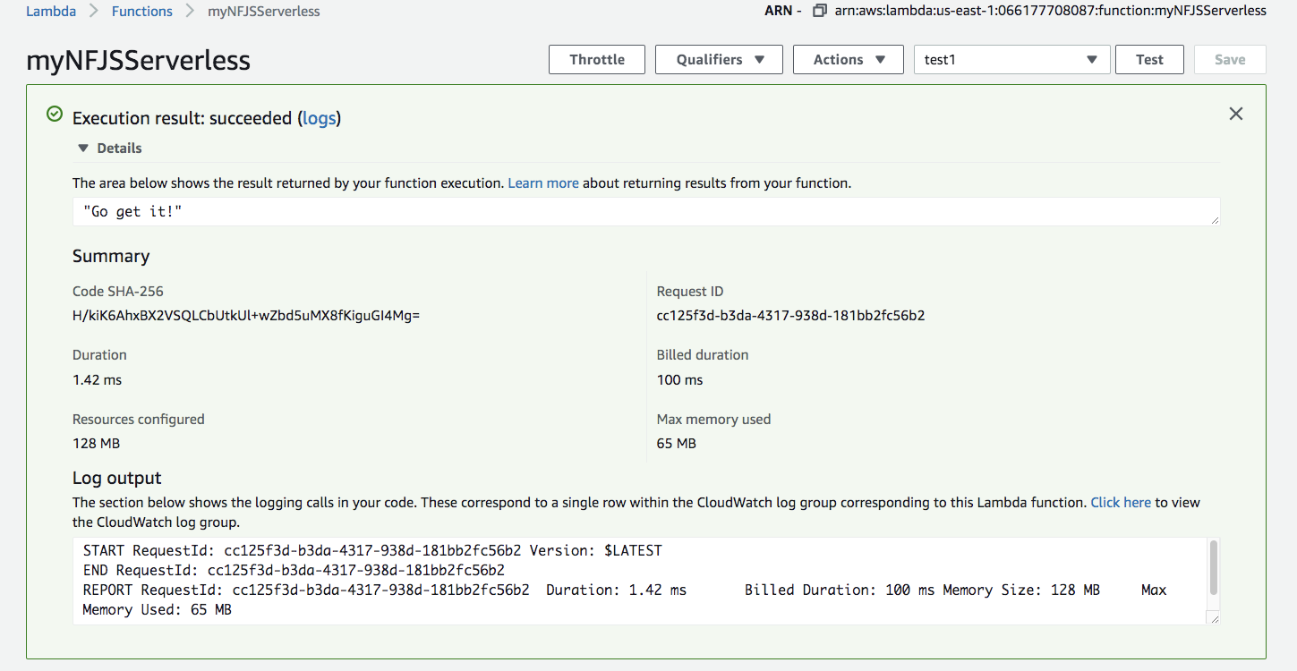

## Examine the Cloud watch logs

